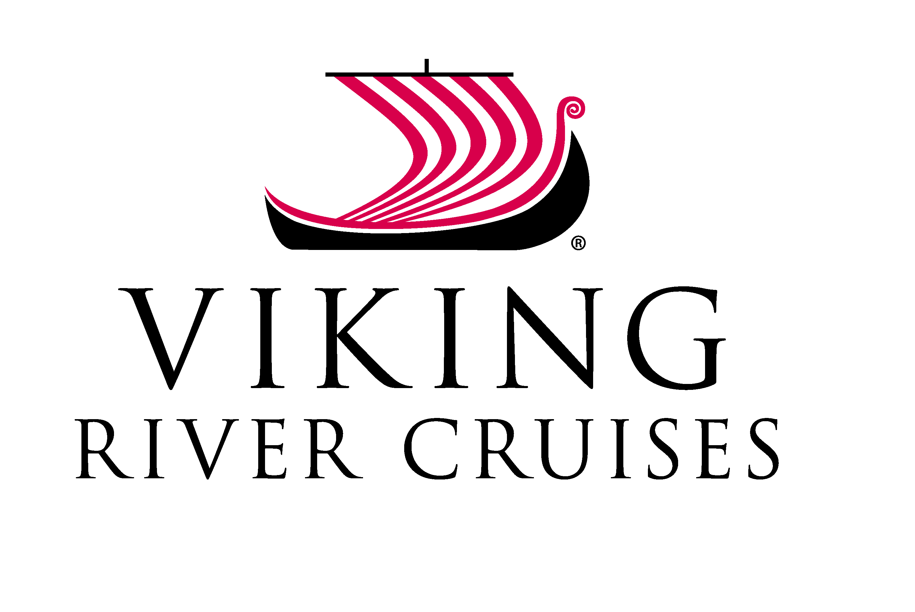
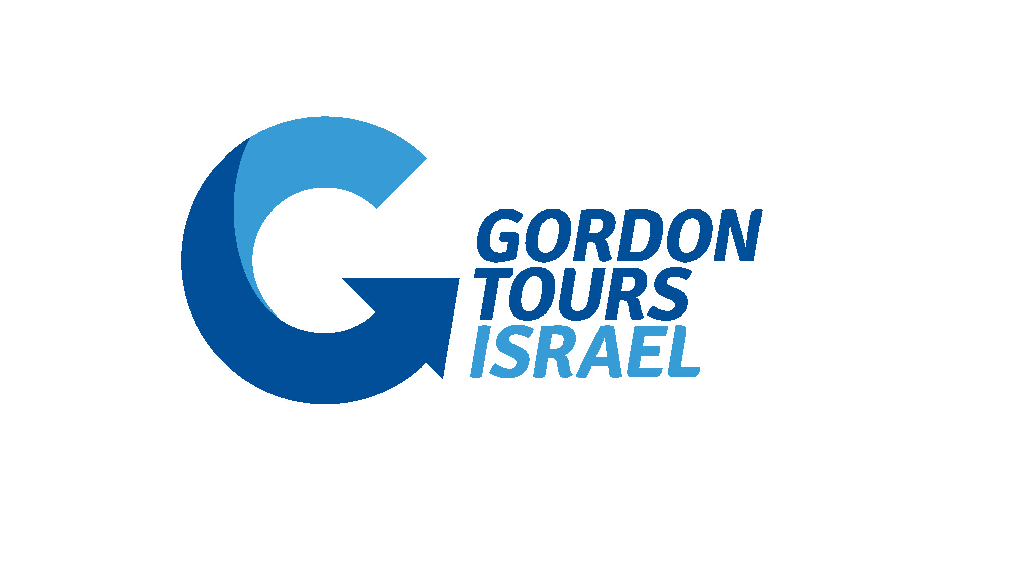

Dear Viking passenger,

Please see below contact information for your stay in Israel:

CONTACT INFORMATION

Local Guide: Mr. Yanay Cohen: +972 (0)52-368-1445

Gordon Tours

Phone: +972 (0)3-7659000 • Emergency: +972 (0)50-205-2459

Our Hostess: Shlomit Ferber: +972 (0)54-3152669

The Hostess will be at your service in the reading room: Thursday: 15:00 PM - 21:00 PM • Friday: 17:00-20:00 PM Saturday: 17:00-19:00 PM • Sunday: 17:00-19:00 PM • Monday: 06:30-8:00 AM

For your next part of the trip, your cruise in Egypt,

enclosed please find your E tickets for your flight to Cairo.
You are booked on Air Sinai (Symbol: 4D) flight 055.

- 4D 055, TLV-CAI, September 23th (Monday), 12:05pm – 12:30pm

Luggage should be out of the room by 7:15am to enable the bellboys to collect it and bring it down. Please be at 8:00am near the reception to identify your luggage before it is loaded to the bus.

Your transfer person will arrive to pick you up from the King David hotel at 8:00am.
Please finalize all checkout formalities before departure.
It is about 45 minutes to one-hour ride to the Airport.

Upon arrival, our Airport representative who will assist you with the check-in formalities will meet you.

We would like to wish you a pleasant and enjoyable tour in Israel and Egypt

Sincerely,

Gordon Tours Israel
(T) +972 - 3 - 765-9000
(E) Info@gordontours.com

